Supplementary information

siRNA preparation
A schematic depiction of the preparation of the siRNAs that we employed in our analysis is shown in Fig. S1. Thus, short-hairpin (sh)RNA was transcribed at 42˚C for 1 hour in a 400μl reaction mixture consisting of 40mM Hepes-KOH (pH 7.8), 20mM MgCl₂, 5mM dithiothreitol, 1mM NTP mixture, 2mM spermidine, 48μg/ml bovine serum albumin, 100nM DNA template (Hokkaido System Science Inc.), 0.47μg/ml bakers yeast inorganic pyrophosphatase (Sigma) and 5.7μg/ml T7 RNA polymerase. The resulting shRNA has single-stranded 5’-GGG and 3’-AU sequences with a 19 bps double-stranded region that is jointed with the trimming loop. The trimming loop contains two specific G residues at the second and last positions in the loop. RNase T1 (10,000U/ml) specifically cleaves shRNAs at these two G residues and the 5’-GGG sequence in limiting conditions in the presence of 100 mM MgCl₂ at 0˚C. The trimmed siRNA was phenol-extracted and purified by native 10% polyacrylamide gel electrophoresis. The quality of the purified siRNAs was confirmed by native PAGE (Figure S2A) analysis and MALDI-TOF mass spectrometry (Figure S2B). The complete double-stranded siRNAs, which cover 70 different designs, are shown in Figure S2A. The mass spectrum that reveals the quality of the siRNA that targets position 50 of EGFP mRNA is shown in Figure S2B. The sense strand (6886.2Da) and the antisense strand (6647.1Da) were detected separately. Although small amounts of the sense strand with a cyclic phosphate and the antisense strand with an extension of C at the 3' end were also detected, they seem to have little effect on the activity of the siRNA because the chemically synthesized siRNAs exhibited comparable activity to the transcribed siRNAs obtained by this method (Figure S2C). The detailed description of this method will be published in a specialized journal.

Legends for supplementary Table S1

List of 702 EFGP siRNAs.
From left to right column for each siRNA, sequence of the passenger strand, energy of passenger strand 5' end, energy of guide strand 5' end, relative stability (g.s.-p.s.), siRNA activity and prediction value are shown.

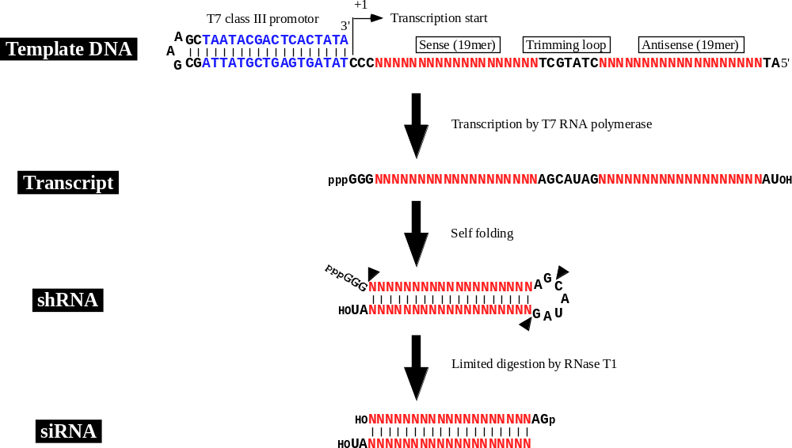

Figure S1

Schematic depiction for the procedure of the transcribed siRNA

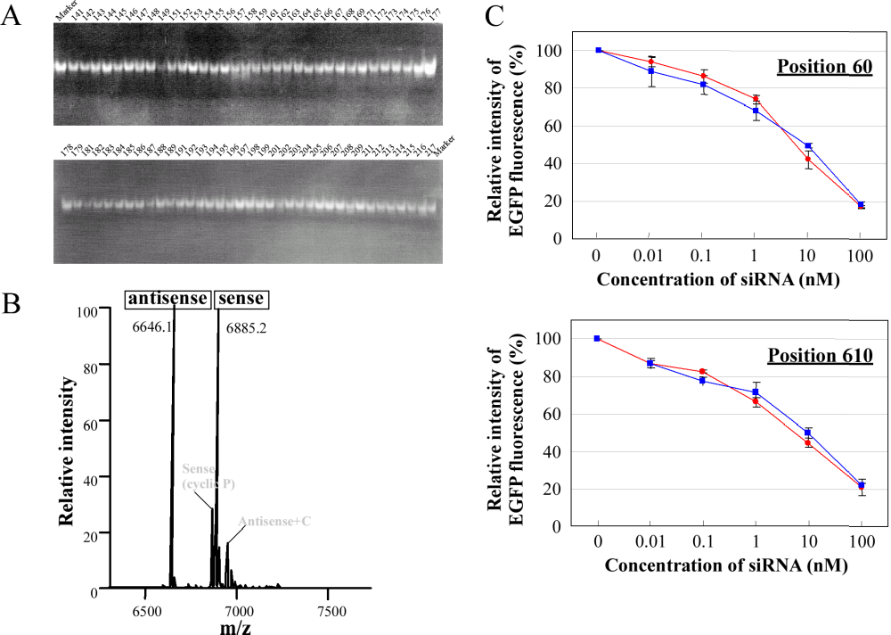
Figure S2

Quality of the transcribed siRNAs
A, Purified siRNAs on 10% native PAGE stained with ethidium bromide. No single-stranded RNA was observed. Target position of each siRNA is indicated on the top of the gel.
B, Purified siRNA targeting position 50 of EFGP mRNA qualified by MALDI-TOF mass spectrometry.
C, The transcribed siRNAs (position 60 and 610) exhibited comparable activities (rectangles) to the chemically synthesized siRNAs (circles).

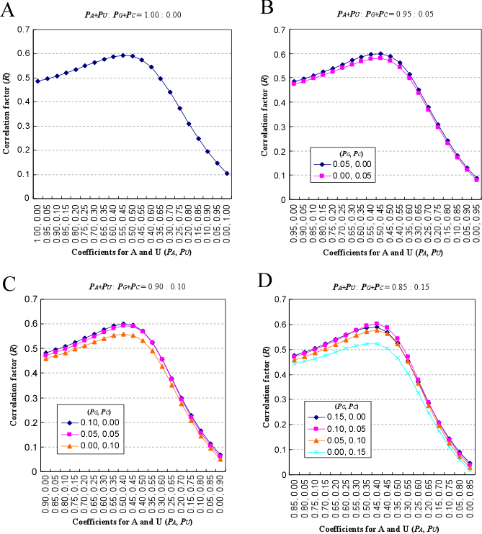
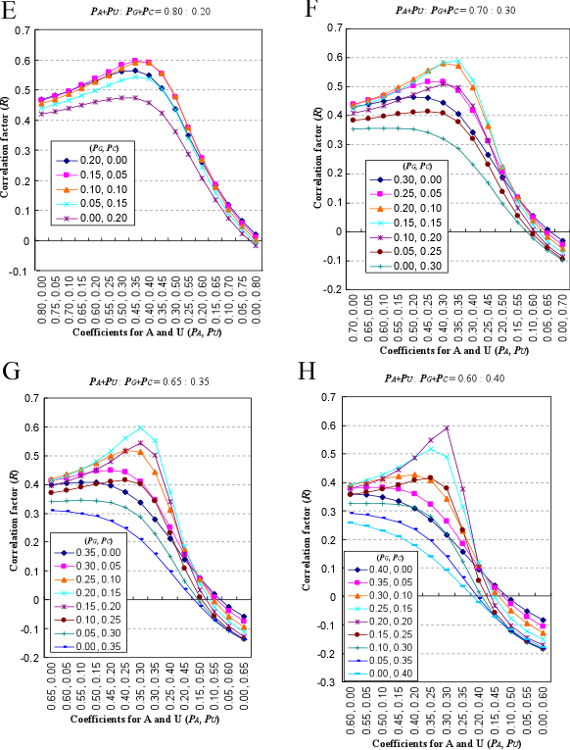
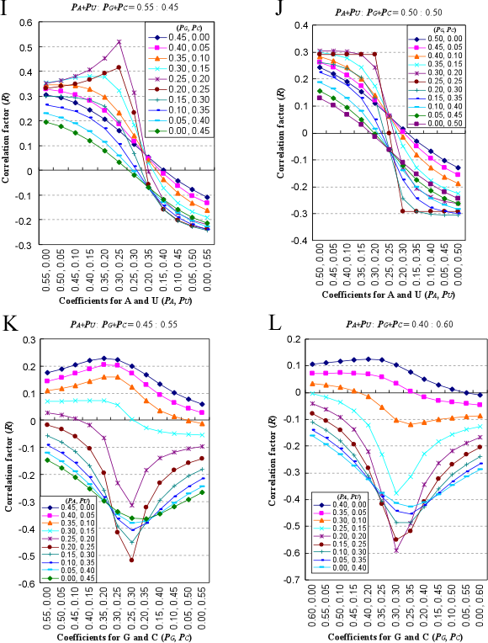
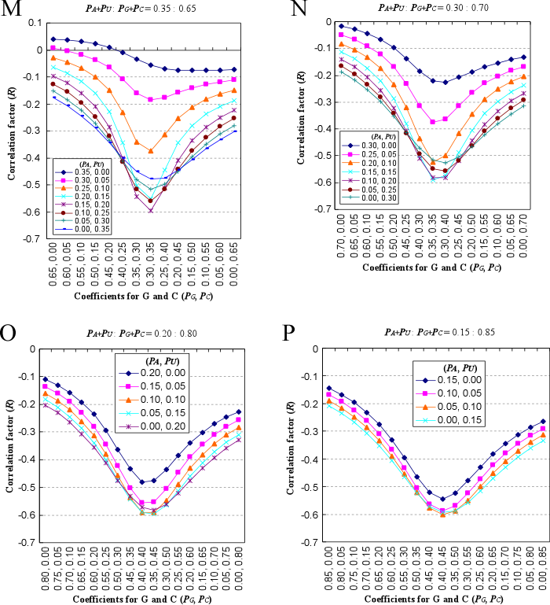
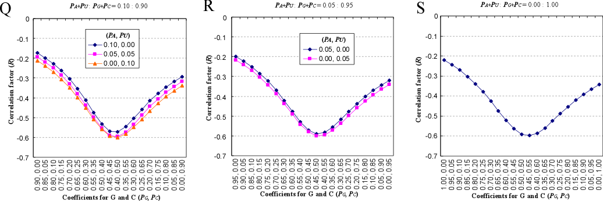

Figure S3A-S
Effect of the total base composition of 702 siRNAs on their ability to silence EGFP expression.
Correlation between the total base composition of the 702 EGFP siRNAs and their activities. The correlation factors are plotted against the different B values that were obtained by changing the coefficients for each base in the formula 1.
Coefficients (A+U, G+C)=(1.00, 0.00) (A), (0.95,0.05) (B), (0.90,0.10) (C), (0.85,0.15) (D), (0.80,0.20) (E), (0.70,0.30) (F), (0.65,0.35) (G), (0.60,0.40) (H), (0.55,0.45) (I), (0.50,0.50) (J), (0.45,0.55) (K), (0.40,0.60) (L), (0.35,0.65) (M), (0.30,0.70) (N), (0.20,0.80) (O), (0.15,0.85) (P), (0.10,0.90) (Q), (0.05,0.95) (R) and (0.00,0.95) (S).

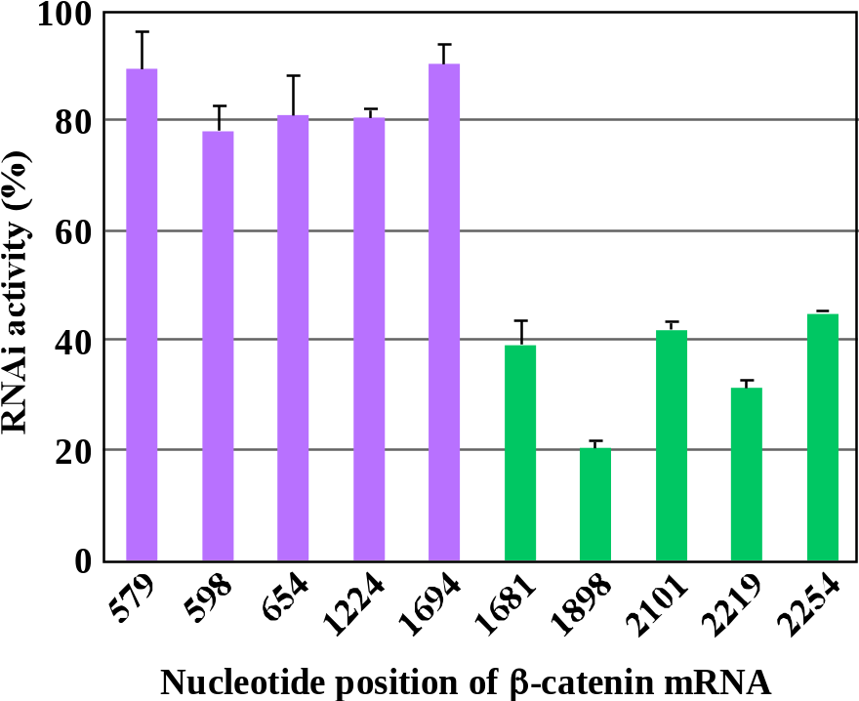

Figure S4
RNAi activities of 10 siRNAs targeting β-catenin mRNA.
Five siRNAs starting with 579, 598, 654, 1224 and 1694 have the prediction values 75-92. The othre five siRNAs starting with 1681, 1898, 2101, 2219 and 2254 have the prediction values 22-42.

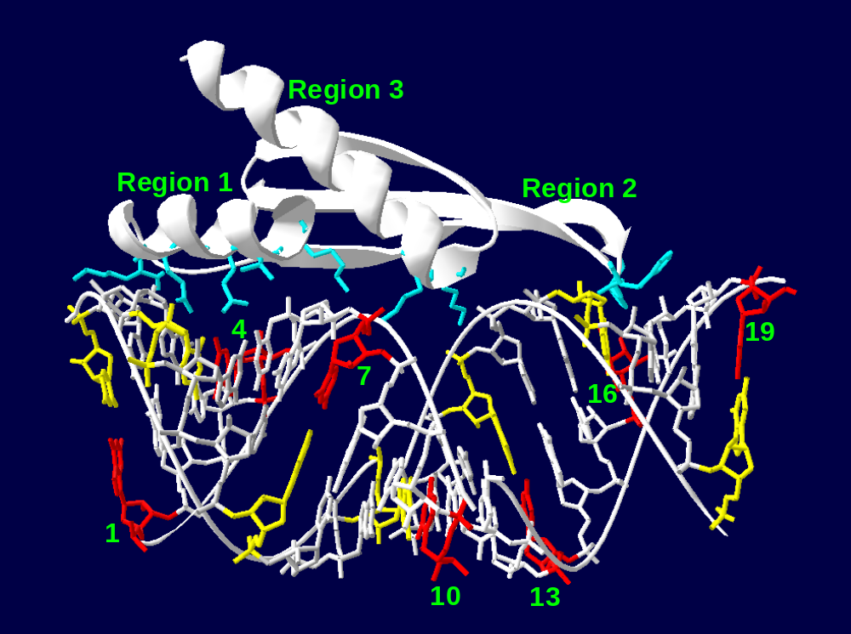

Figure S5
Base-pairs at position 3n+1 align straight lines on the two opposite faces of A-form helix of siRNA
Bases at position 3n+1 (1,4,7,10,13,16 and 19) are shown in red and yellow in each strand in crystal structure of Aquifex aeolicus RNase III-dsRNA complex (55). dsRBD binds to the one face of the A-form helix of dsRNA. Side chains of amino acid residues involved in dsRNA recognition are shown in blue.

